Interview questions of JPMC (Win forms, oracle, N-unit):
- Tell me about your technical background.
I have worked on ASP.NET, MVC 4, Entity Framework, Ajax, JQuery, Orchard CMS, nopCommerce, Angular JS, C#.
We Follow:
It is social networking website for Companies where AN organisation can share their official and non-official updates to their employees. Project Managers and employees can create their groups to share the project updates and project related requirements and planning’s.
I have used ASP.NET, MVC 4, Ajax and JQuery in this project.

- Project architecture
Presentation Layer
-Web Pages, MasterPage, Admin Page and Error Pages and Exception Handler.

Business Login Layer
Admin, Organisation Admin ,Project Manager, Employees, Vendors Business Rules and Validation Rules.

Data Access Layer
User Tables, Registered Company tables, Company Subscription Package Table, Users Post Table, organisation post table.
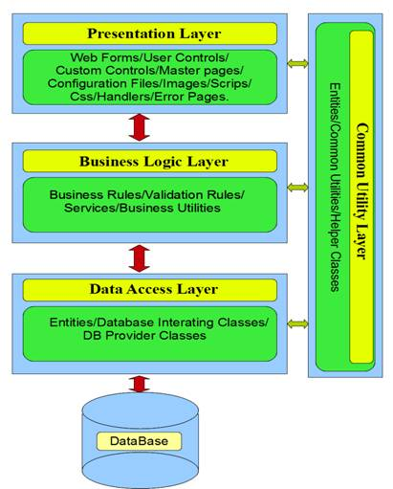

- Your roles and responsibility
- Creating Web pages for Organisation Admin, Project Manager, Employees and Vendors.
- Creating Database tables for employees, Organisations, Admin users, Media.
- Creating UI using bootstrap and CSS3.
- Creating webpages using AJAX to get the latest post from the users and organisation without refreshing the web page.

- New features of dot net
http://www.developer.com/net/asp/top-10-features-in-asp.net-4.5.html
- Have you worked on windows forms
- What you did, means how you create the forms
- SQL server transaction handling
- Nunit testing how you are doing?
http://www.nunit.org/index.php?p=quickStart&r=2.4
- Performance of application how improve
http://www.c-sharpcorner.com/uploadfile/skumaar_mca/tips-to-improve-the-performance-in-Asp-Net-application/
- Viewstate
- Avoid Session and application variables
- Use Caching
- Effectively use CSS and Script files
- Image Sizes
- CSS Based layouts
- Avoid Round trips
- Validate using Javascript
- Clear the garbage collection
- Avoid Bulk data store on client side
- Implementing Dynamic paging
- Use Stored procedure
- Use XML and XSLT
- Use Dataset
- Use server.transfer
- Use threads
- Performance of SQL, how recognize and how improve?
- https://msdn.microsoft.com/en-us/library/ff647793.aspx
- http://www.developer.com/db/slideshows/10-ways-to-improve-sql-query-performance.html
- How MVVM works
https://www.codeproject.com/Articles/278901/MVVM-Pattern-Made-Simple
http://www.wintellect.com/devcenter/jlikness/model-view-viewmodel-mvvm-explained
- How you are tackle the production issues?
- Scenario based some questions on sql database,
- Scenario based question, on oops concepts(inheritance, polymorphism, abstraction)
- Static classes why use
http://www.c-sharpcorner.com/interview-question/why-we-use-static-class
Static class is used because it does not allow user to create instances of a class as well as it restricts the user to inherit any data members/functions to derived class
So a static class can make your implementation simpler, safe and faster because you don’t have to create an object in order to invoke its method.
Also the data member/functions can be called directly using the class name and there is no need to create the object.
- Design patterns –which one you used?
https://www.codeproject.com/Articles/738043/Design-Patterns-in-ASP-NET
https://csharpdesignpatterns.codeplex.com/
- How will you create the database tables from scratch?
- Garbage collection with generations
http://stackoverflow.com/questions/2257563/what-are-the-generations-in-garbage-collection
- How you will use legacy code in your application?
http://stackoverflow.com/questions/7312504/c-sharp-unit-testing-mocking-legacy-code
http://www.daedtech.com/intro-to-unit-testing-5-invading-legacy-code-in-the-name-of-testability/
- What challenges you face in your project.
- 1> how to make Singleton pattern thread safe.
- 2> A simple cross join
- 3> Factory design pattern
4> How to improve performance of select query
- 5> Page life cycle
- 6> Viewstate, Session
- 7> XML file related questions

- How does ModelBinder/MVC bind values from view/client browser to Model? How does it identifies which control value to bind to certain Model property?
- What is MVC, how does it works?
- What are then Status and ready readyState property of XMLHttp object and what are the possible values for them.
- What will be the values Status and ready readyState in case of exception handled and not handled server function?
- What is magic tables in SQL server?
- What are the function type in Database, Sql Server or Oracle?
- How to fetch collection of data from stored procedure in managed code?
- How does session state works in asp.net? What is InProc and OutProc session management and how does session object passed to/from session state process to asp.net working process?
- Difference between primary and unique key?
- Type of index? How clustered and non- clustered index works?
- What the difference between online and multiline JavaScript function?
- How to access first column of all the rows in html table/grid in Javascript?
- What setTimeOut in JavaScript?
- What is Anonymous function, both in JavaScript and c#?
- Difference between == and === operator n JavaScript?
- What is ABC in WCF?
- What is Contract , what types of contracts are there?
- Does signature Not marked as operation contract needs to be implemented service class?
- What exception it would be if operation marked and not marked member of service contract implemented and not implemented in service class?
- How to show gird in MVC view?
- Can wcf / web service return dictionary or hashtable data?
- How does operating system knows about .net assembly when deployed?
- Count (*) vs count(colum). ?
- Type of delegates ?
- keyword default
- yield return
- How you will use legacy code in your application?
- Security in WCF
- What are the transport methods used in WCF??
- WCF Built-in Bindings and its type and which binding in fastest.
- Hosting of WCF services?

